**GDD**

**Main Concept**

A 3D scene showcasing a Level for a potential game level. The theme is a Sci-fi Scientific Lab and the gameplay that could potentially be added to the level would be a Horde Survival game.

**Story**

A sci-fi Scientific Laboratory in the arctic that has experienced a breach from their experiment that was encased in Ice, causing unprecedented amounts of damage and chaos, and has recently been abandoned by all researchers, the bodies where not retrievable after the event but now, the bodies are nowhere to be seen.

**Level Design**

The level will consist of 3 different floors, here they are:

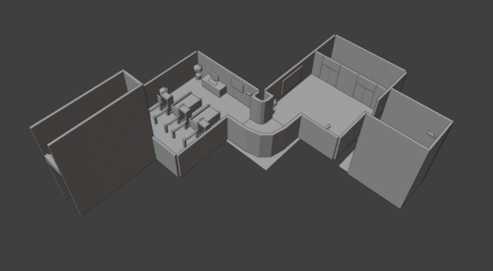**Floor 0**

Spawning area that contains security meant for small breaches and/or deterring unwanted visitors, it connects to the elevators that brings you to the next floor.

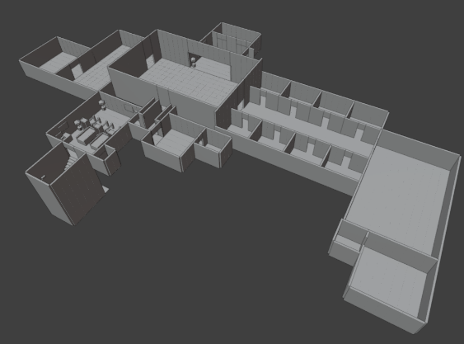**Floor -1**

This floor is dedicated to creating a liveable habitat for the human researchers. It contains a Cafeteria, Medical Ward and light entertainment. It is also the floor that contains all the servers for the Laboratory and access to the final floor.

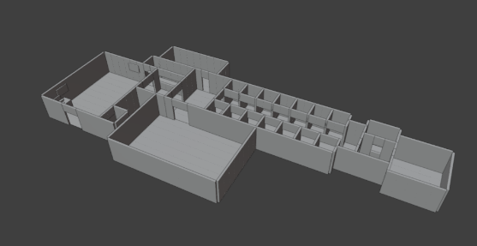**Floor -2**

This floor is dedicated to researching and experimenting with the entity that was discovered deep within the ice. It contains lots of security with 2 checkpoints between the Upper floors, Experimental Chambers and Entity’s Containment Cell found at the very end of the corridor. It also has an armoury for personnel to utilise in-case of emergencies.

**Art**

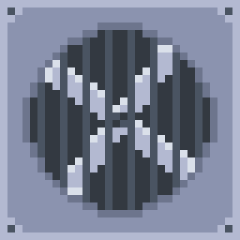The textures used in the scene will be pixel-art made by me using Aseprite. I’m creating all the textures manually, including Roughness, Normal, Height and Emissive textures using different layers on the same file on Aseprite to quickly create more and more textures efficiently and easily.

**COLOUR ROUGHNESS NORMAL HEIGHT**

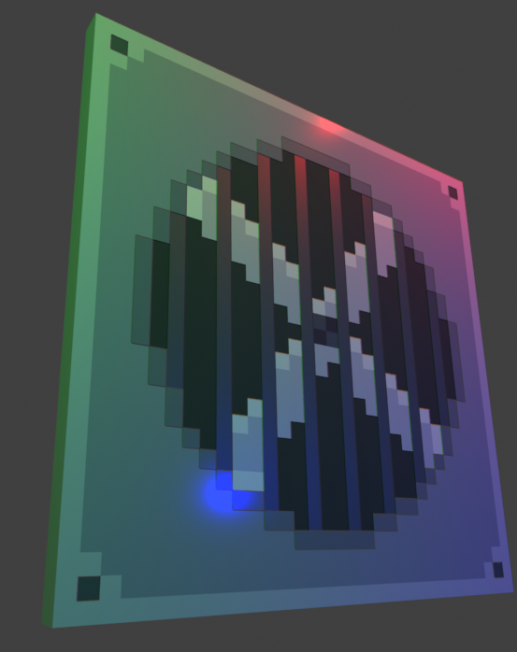**The Result of these Textures:**

**VFX**

All the VFX will be made in Blender itself. I will add various particle effects to add life to the scene, have animated textures on various surfaces and add lighting and shadows for a cinematic look.